PAPER TITLE – USE CAPITAL LETTERS, CENTER, BOLD, TIMES NEW ROMAN, SIZE 13, DO NOT USE ABBREVIATIONS HERE
MSc. Eng. arch. Name SURNAME¹ - Times New Roman, 11 pt
MSc. Eng. arch. Name SURNAME² - Times New Roman, 11 pt
¹ Name of the Company/University, Country - Times New Roman, 9 pt
² Name of another Company/University, Country - Times New Roman, 9 pt
Remark: If all authors are from the same university it is not necessary to use numbering/superscript for each author’s name (remove this remark during edition)

ABSTRACT
An informative and short abstract (10–15 lines, Times New Roman, 10 pt) should be given at the beginning of the paper. Brief description of the study and used methods. Brief description of the study and used methods. Brief description of the study and used methods. Brief description of the study and used methods. Brief description of the study and used methods. Brief description of the study and used methods. Brief description of the study and used methods. Brief description of the study and used methods. Brief description of the study and used methods. Brief description of the study and used methods.
Keywords: keyword1, keyword2, keyword3…(Up to five key words that summarize the contents of the paper, Times New Roman, 10 pt)

INTRODUCTION (main heading 11 points, bold, in capital letters)
It is strongly recommended to use this template and to input your paper text into it. Use A4 paper, portrait, margins: left / right 3 cm, top / bottom 3 cm, header / footer 1.5 cm. Alignment: justify. The main body of the paper should be written in Times New Roman 11 point font, colour black, line spacing at least 13 points at a full length of line, i.e., 15 cm; each new paragraph should start with a 0.5 cm indention. Spacing between paragraphs: 0 pt before, 6 pt after. It is not recommended to leave additional blank lines between paragraphs. Do not start a new paragraph in the last line of the column and avoid typing the last line of the paragraph on a new column. The last line of a paragraph should contain at least 5 characters. Text pages must be produced to the maximal stipulated length. Please use the Alt 0150 code for a dash to represent ranges, e.g., 3–45 MPa and do not use slash marks in place of parentheses. Do not edit the given page numbers or the page footer – they are to be completed by the Publisher.
Papers will be reproduced exactly as submitted and will not be edited in any way. Abbreviations should be kept to a minimum. Use of standard abbreviations is acceptable. Place special or unusual abbreviations in parentheses after the full term for the first time it appears. Linguistic accuracy is the responsibility of the authors. Please note that the paper should contain not less than 20 thousand typographic characters (with spaces) and not exceed 12 pages at maximum including text, figures and tables. Papers should be written in English language.
Style for Figures (sub-heading 11 points, bold)
Illustrations, including their captions should fit into text area. Drawings, diagrams and photographs should be numbered consecutively 1, 2, ..., n. Captions given in English should be centered. Leave one line space between the figure and the text. If an illustration is very small, you may impose the caption or continue the text next to it, and the rule is that it should be placed in the left part of even numbered pages, and in the right part of odd-numbered pages. Drawings (figures, charts) should be prepared with minimum line weight 1pt.
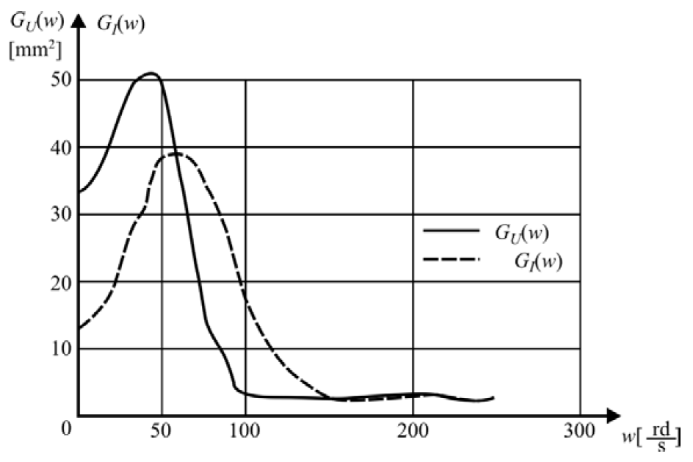
Fig. 1. For figure caption (9 points)

Mathematical formulae should be typed using font size 11 points. They should be centered and numbered in parentheses on the right-hand side. All symbols representing variables should be typed in italics, both in the formulae and in the text. Also text in indexes, excluding two and three letter abbreviations created from the first letters (i.e. i_{kr}), should be written in italics. shortcuts of mathematics functions (i.e. sin, cos) should be typed in normal text. Leave one line space between the text and the formula. Tables (including captions) should be typed using font size 9 points, line spacing at least 11 points.
(1)
In case two elements requiring additive space (formula and table, illustration and table, main- and sub-heading) come next to each other, please remove the space after the first element.
Table 1 For table heading (9 points)
Year | 2003 | 2004 | Average
Efficacy I type | 70.00% | 80.00% | 75.00%
Error I type | 30.00% | 20.00% | 25.00%
Efficacy II type | 70.00% | 60.00% | 65.00%
Error II type | 30.00% | 40.00% | 35.00%

If further text along with it’s heading does not fit into the page, please move it to the beginning of next page, without any space before it.

REFERENCES (9 points)
Particular items referred in the text should be given on-line by bracketed numerals, e.g., [3]. References should be given in the style presented below, with the names of authors being listed in alphabetical order – font size 9 points, line spacing at least 11 points. References should be complete with the surnames of all authors, initials(s) of the first name(s), title of the paper (indicate the number of consecutive edition or volume), name of the journal the article is taken from, place of publication, editors, year, number (in the case of journals), the inclusive page range. For references in the Russian language, either the Cyrillic alphabet can be used or transliteration should be made.
[1] BOCEWICZ G., BANASZAK Z., WÓJCIK R., Design of admissible schedules for AGV systems with constraints: a logic-algebraic approach, In: Agent and Multi-Agent Systems: Technologies and Applications, Nguyen N.T., Grzech A., Howlett R.J., Jain L.C. (Eds.), Berlin, Springer-Verlag, 2007, 578–587.
[2] NOWACKI W., Plasticity of polycrystal, Warszawa, PWN, 1987, 687–704.
[3] ASHIMOV A., BOROVSKIY Yu., ASHIMOV As., Parametrical Regulation Methods of the Market Economy Mechanisms, Systems Science, Vol. 35, No. 1, 2005, 89–103.

SUMMARY (title in Polish)
A short summary (8–12 lines) in Polish. Recommended type face is 9 points, Times New Roman CE, line spacing at least 11 points, beginning with a 0.5 cm indention.

REMARKS: (remove these remarks during edition)
- Authors must present the manuscripts in English language;
- Volume of paper: minimum: the paper should contain not less than 20 thousand typographic characters (with spaces); maximum: 12 typewritten pages, including: title, author/s, abstract, real text, charts, drawings and literature/references;
- The paper should be delivered no later than on the day of the paper presentation at the conference

